**Worksheet 3.2 or 9**

**Student Name:** Vivek Kumar **UID:** 21BCS8129

**Branch:** BE-CSE (LEET) **Section/Group:** ON20BCS-809/A

**Semester:** 4th Sem **Date of Performance:** 08/04/2022

**Subject Name:** MPI Lab **Subject Code:** 22E-20CSP-253

**1. Aim/Overview of the practical:**

1. Find the smaller out of two numbers.
2. Find the larger out of two numbers.

**2. Task to be done:**

Write an 8085 Microprocessor program to find the smaller & higher number out of two number.

**3. Apparatus/Simulator used (For applied/experimental sciences/materials-based labs):**

1. 8085 Jubin simulator version 2 (Microprocessor Simulator)
2. Java (jdk/ jre1.8.0_321)

**4. Algorithm/Flowchart (For programming-based labs):**

**Algorithm to Find the smaller out of two numbers:**

1. Load the data to Memory from 1000 address using Immediate Instruction **LXI H, 1000**.
2. Move The data from Memory 1000 to Accumulator ‘A’.
3. Increment the HL pair using **INX H**.
4. Move The data from Memory 1001 to Register ‘B’.
5. Compare Register B with Accumulator using **CMP B**.
6. Check if Carry flag generated using **JC** Instruction.
7. If carry flag generated and set to 1 jump to the label and store the value of Accumulator ‘A’ to 1002 using **STA 1002**.
8. If carry flag not generated then move the Register ‘B’ to Accumulator ‘A’ then store the value of Accumulator ‘A’ to 1002 using **STA 1002**.
9. End the execution using HLT.

**Algorithm to Find the larger out of two numbers:**

1. Load the data to Memory from 1000 address using Immediate Instruction **LXI H, 1000**.
2. Move The data from Memory 1000 to Accumulator ‘A’.
3. Increment the HL pair using **INX H**.
4. Move The data from Memory 1001 to Register ‘B’.
5. Compare Register B with Accumulator using **CMP B**.
6. Check if Carry flag generated using **JNC** Instruction.
7. If carry flag not generated jump to the label and store the value of Accumulator ‘A’ to 1002 using **STA 1002**.
8. If carry flag generated and set to 1 then move the Register ‘B’ to Accumulator ‘A’ then store the value of Accumulator ‘A’ to 1002 using **STA 1002**.
9. End the execution using HLT.

**5. Description/ Code:**

**Program to Find the smaller out of two numbers:**

# ORG 0900H

LXI H,1000

MOV A, M

INX H

MOV B, M

CMP B

JC LABEL

MOV A, B

LABEL: STA 1002

HLT

# ORG 1000

# DB D7H, F6H

**Program to Find the larger out of two numbers:**

# ORG 0900H

LXI H,1000

MOV A, M

INX H

MOV B, M

CMP B

JNC LABEL

MOV A, B

LABEL: STA 1002

HLT

# ORG 1000

# DB D7H, F6H

**6. Result/Output/Writing Summary:**

**Output to Find the smaller out of two numbers:**

When 1st number is smaller number

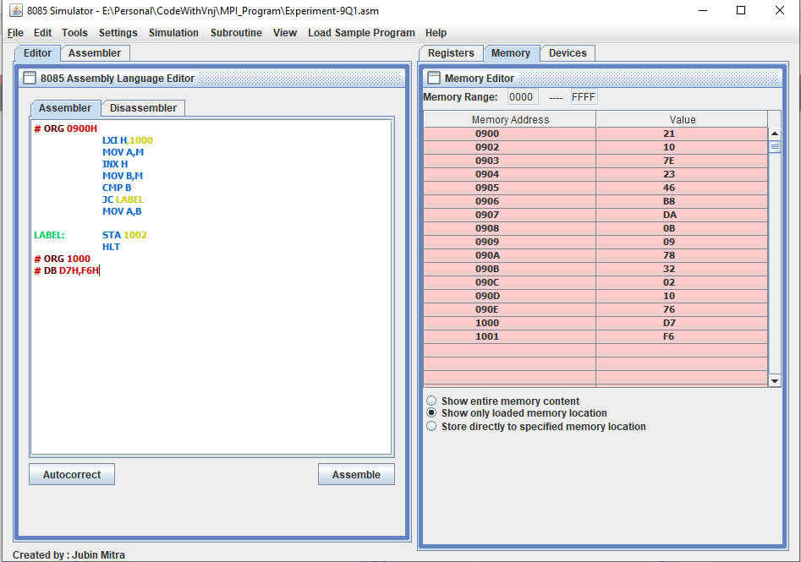

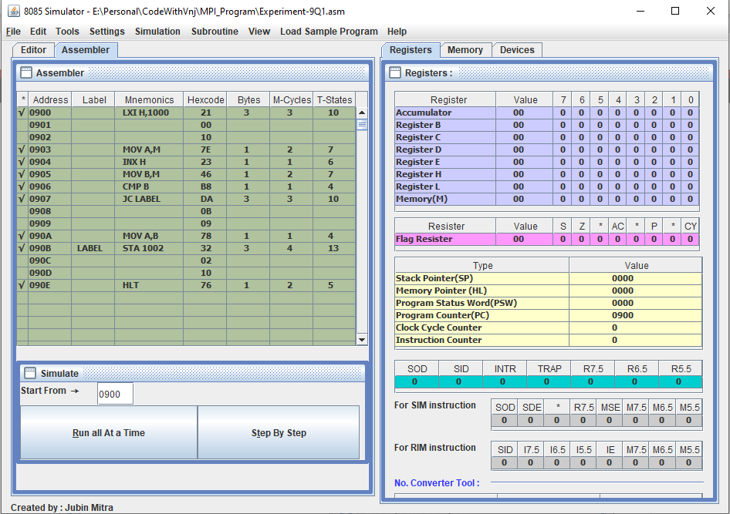

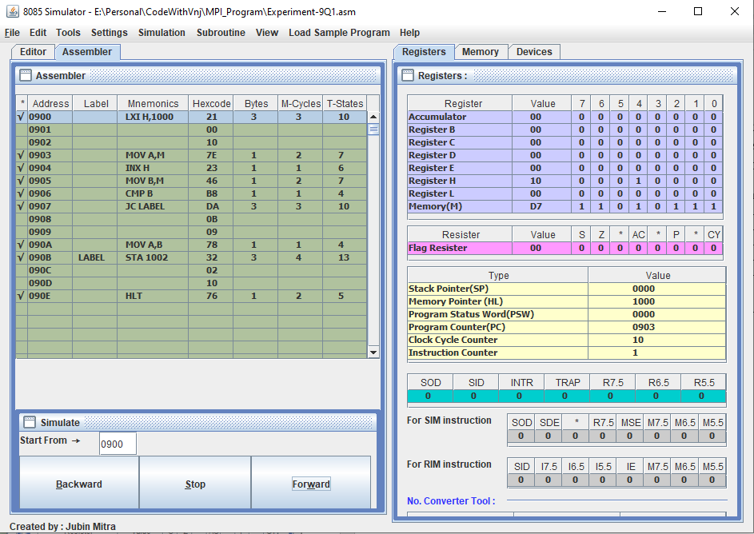

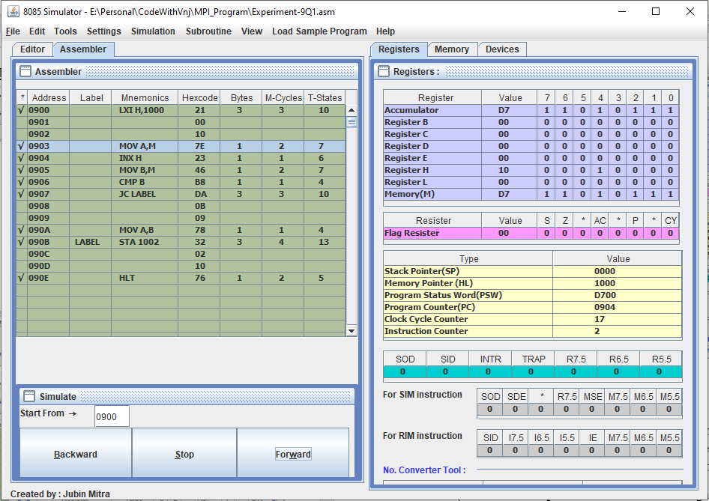

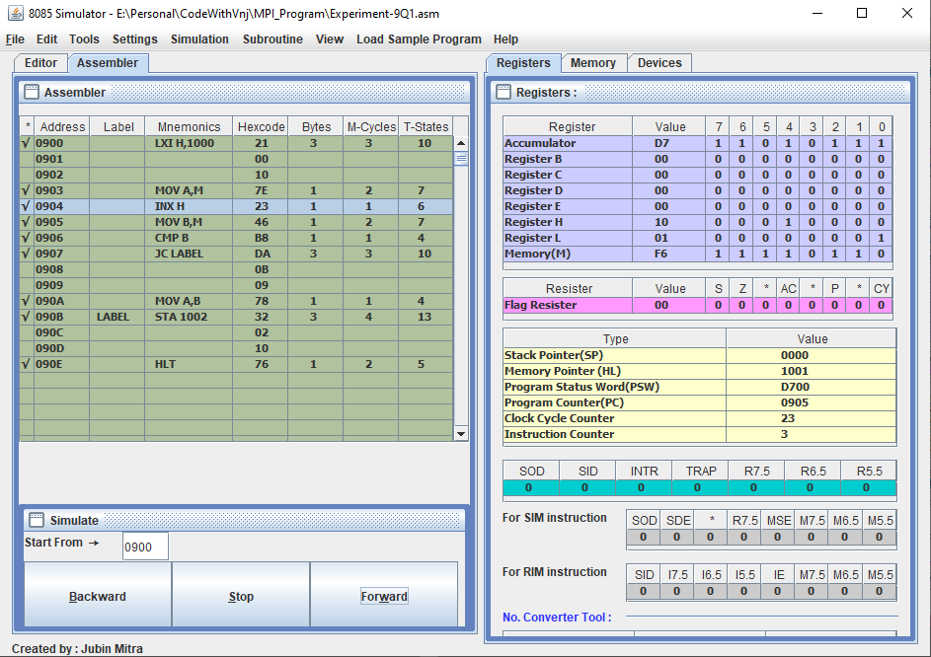

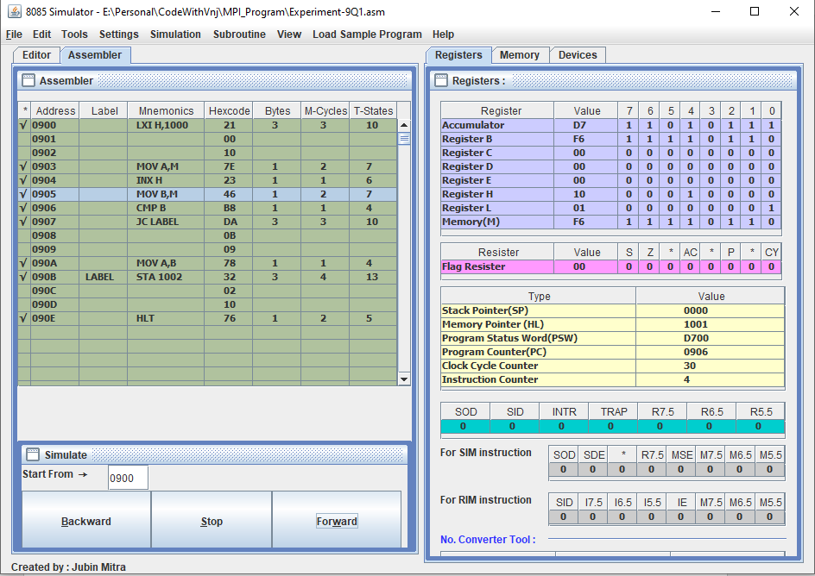

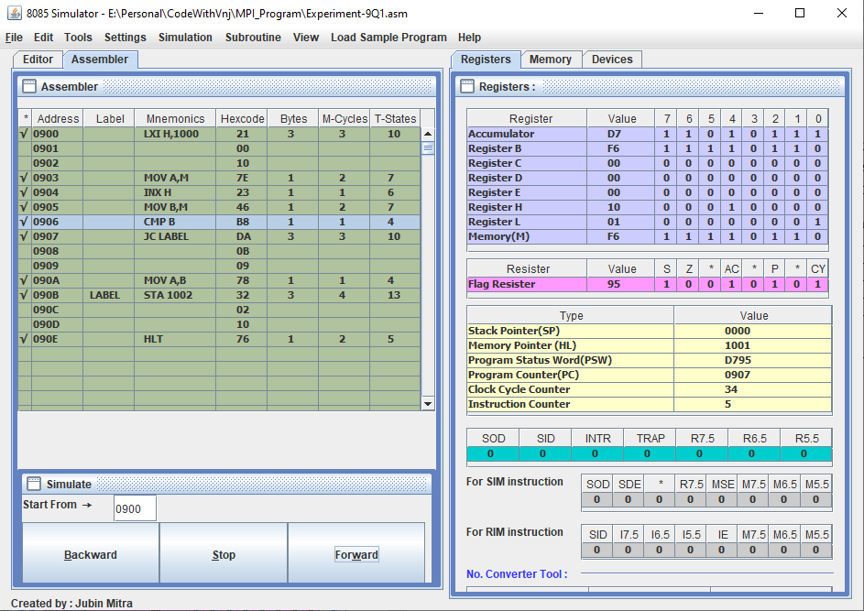

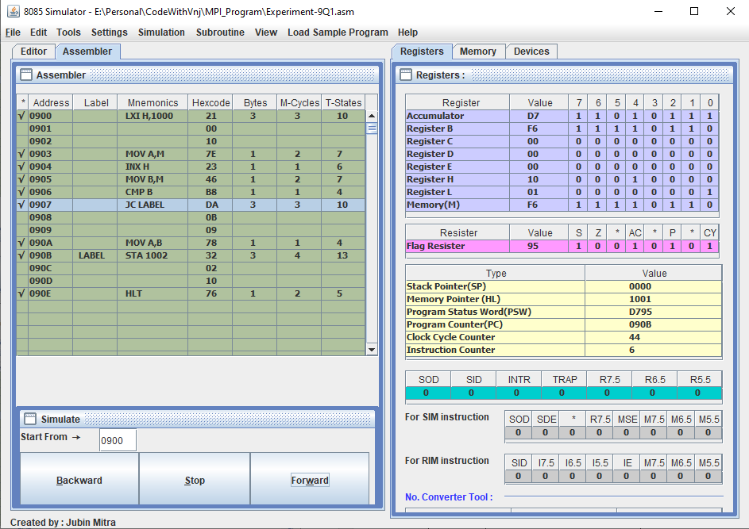

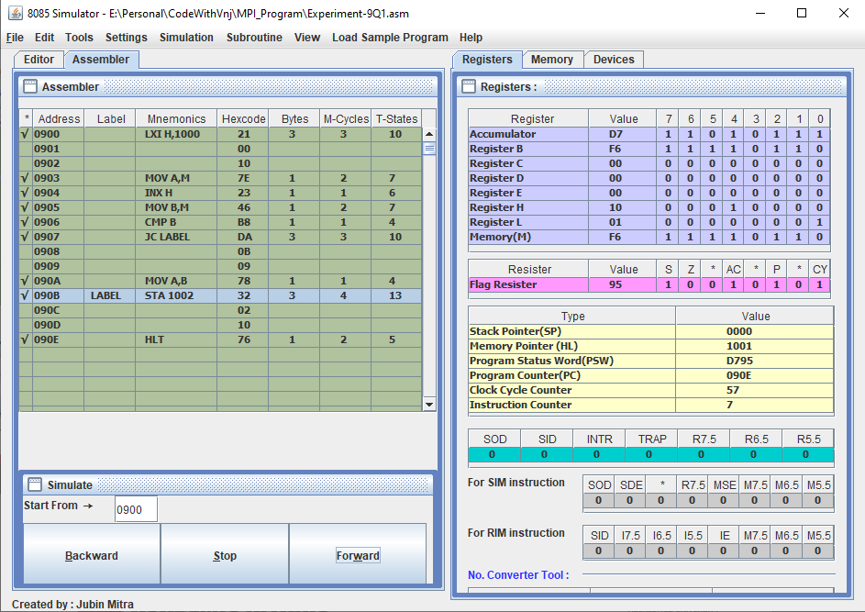

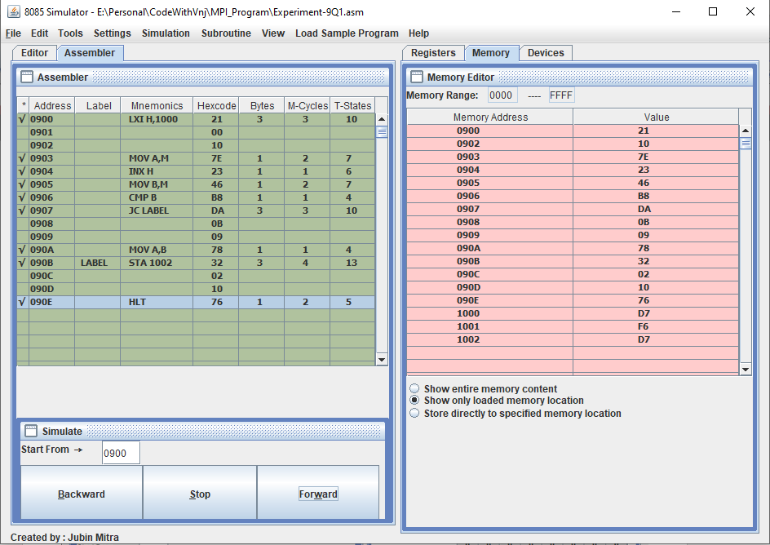

When 2nd number is smaller number

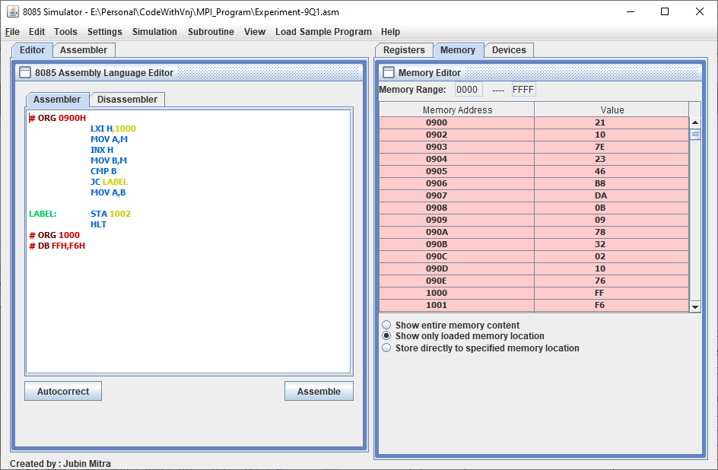

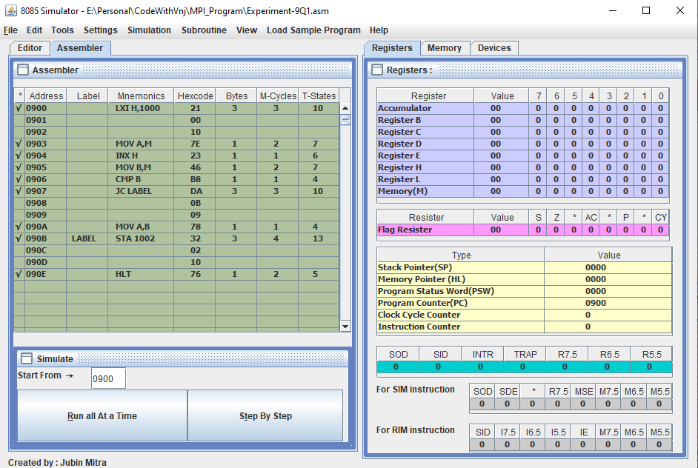

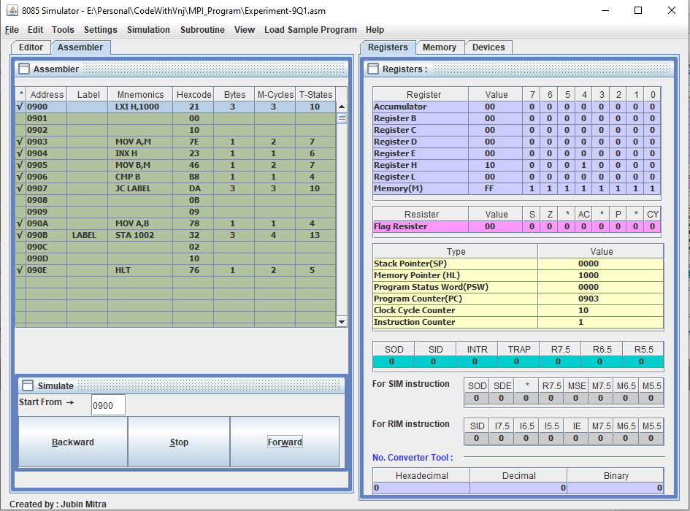

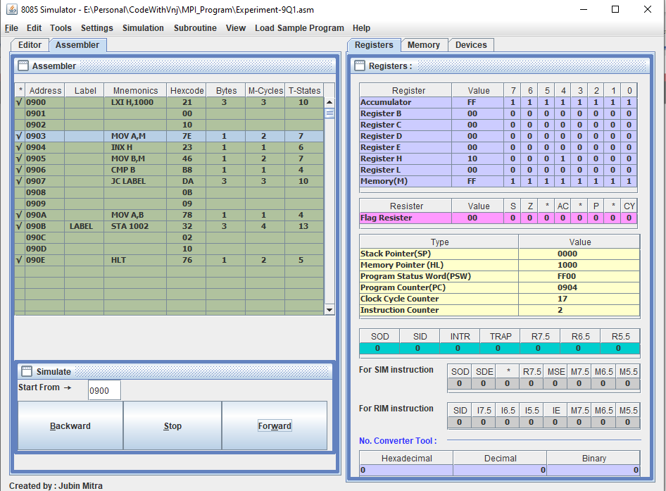

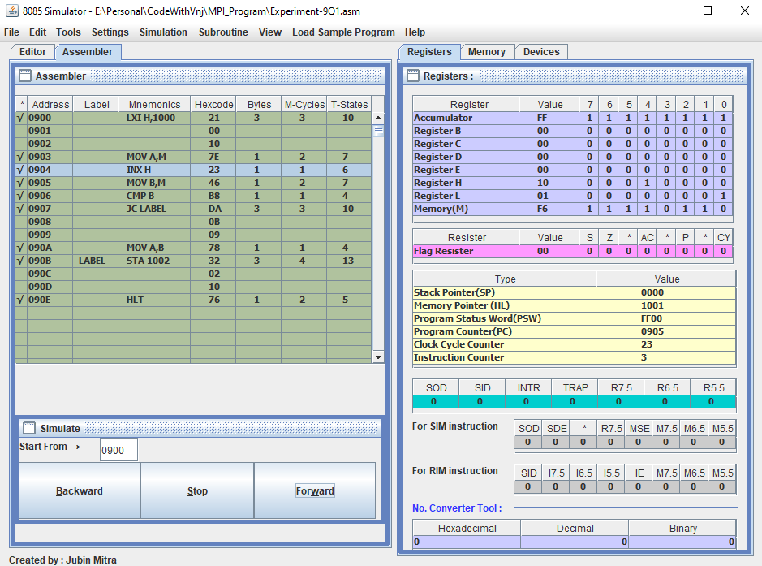

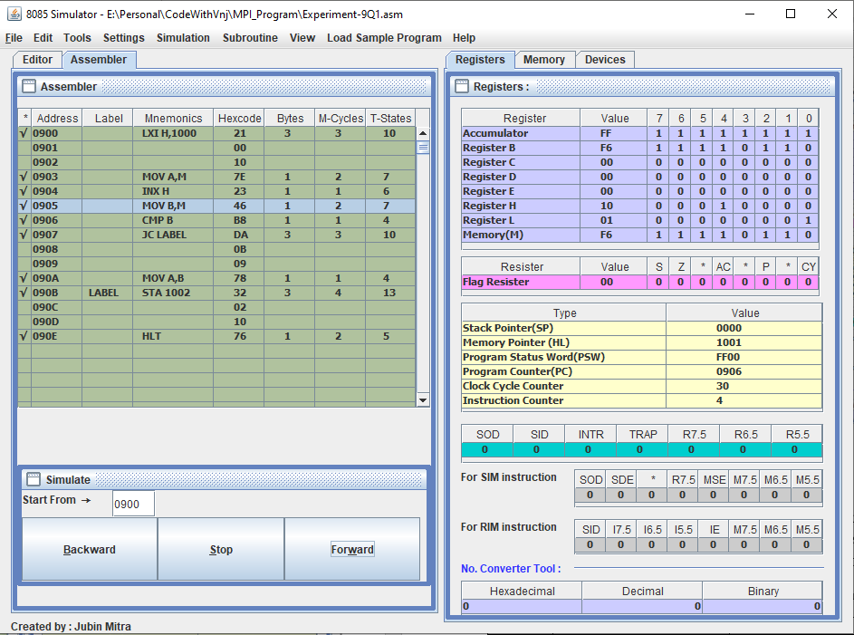

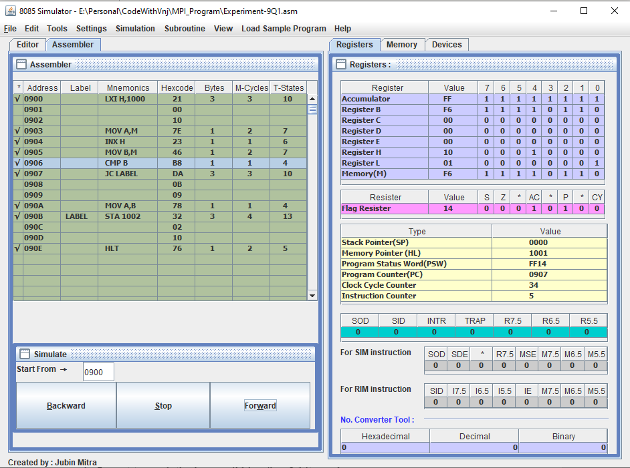

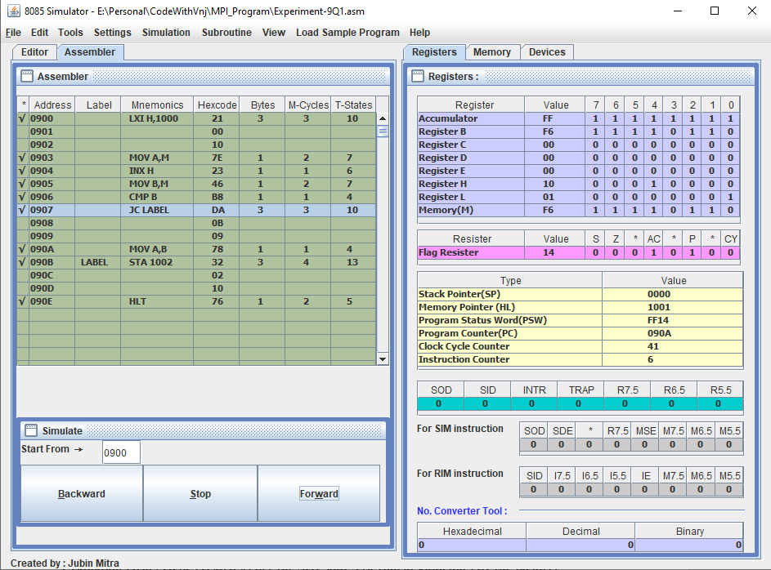

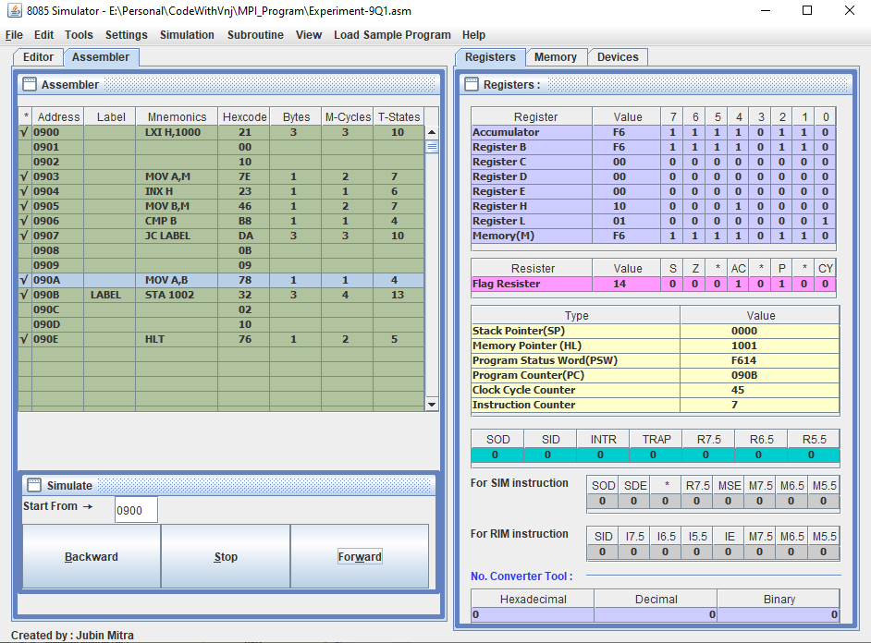

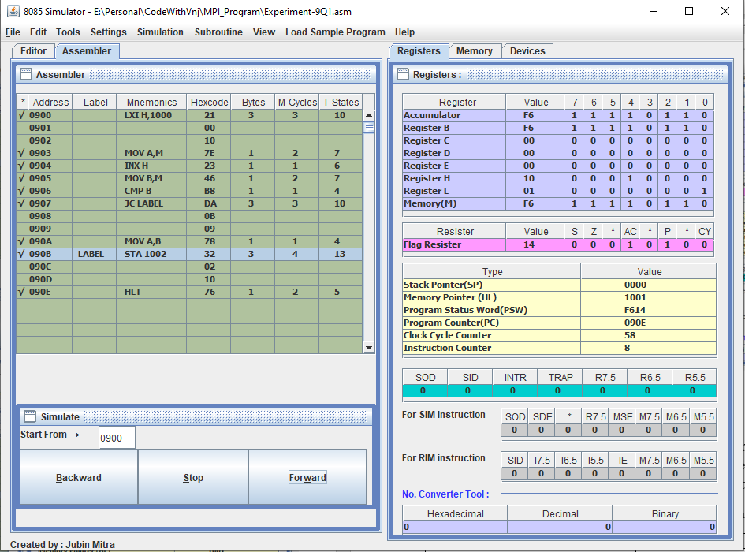

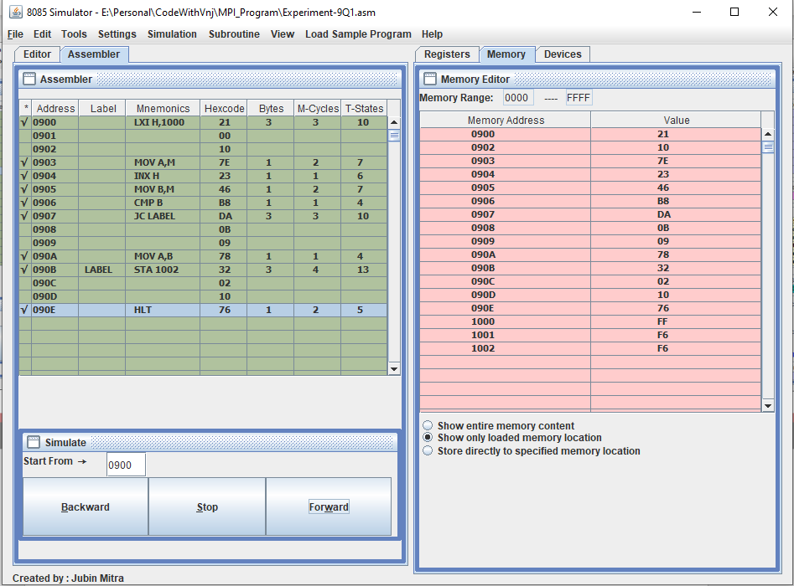

**Output to Find the larger out of two numbers:**

When 2nd number is larger number

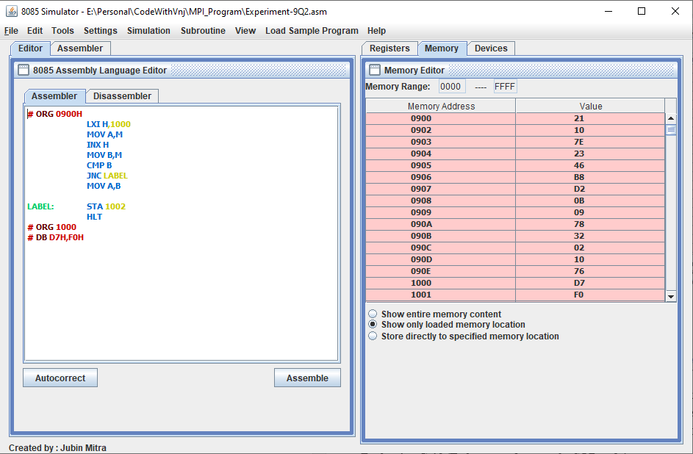

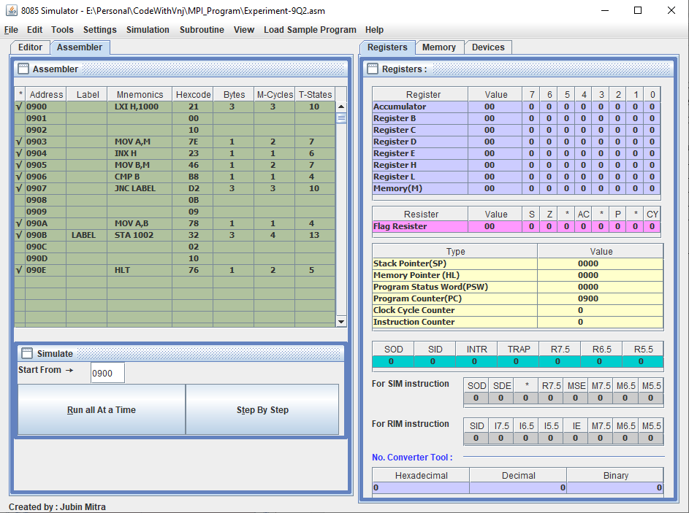

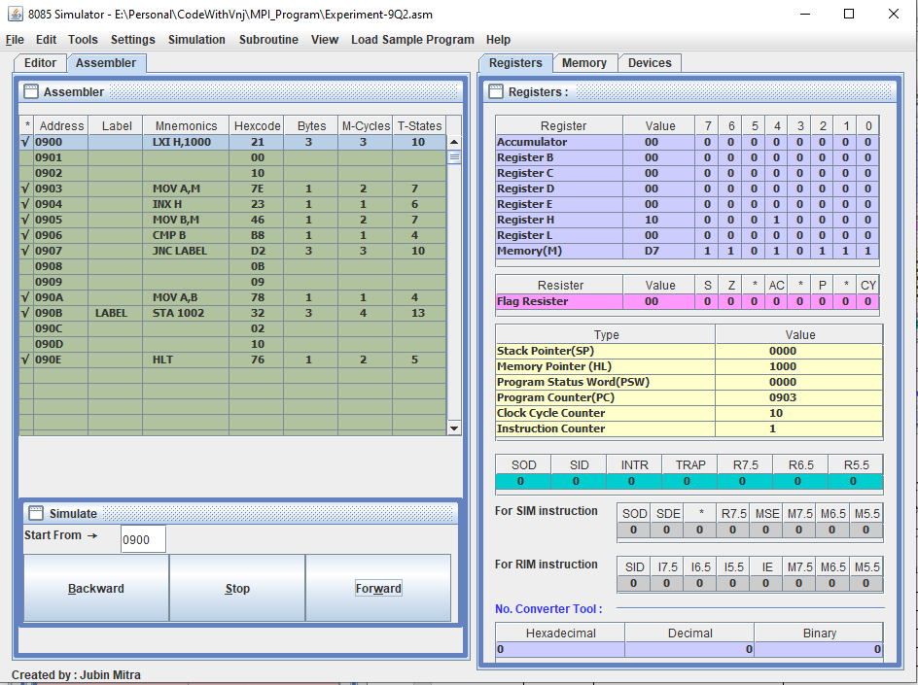

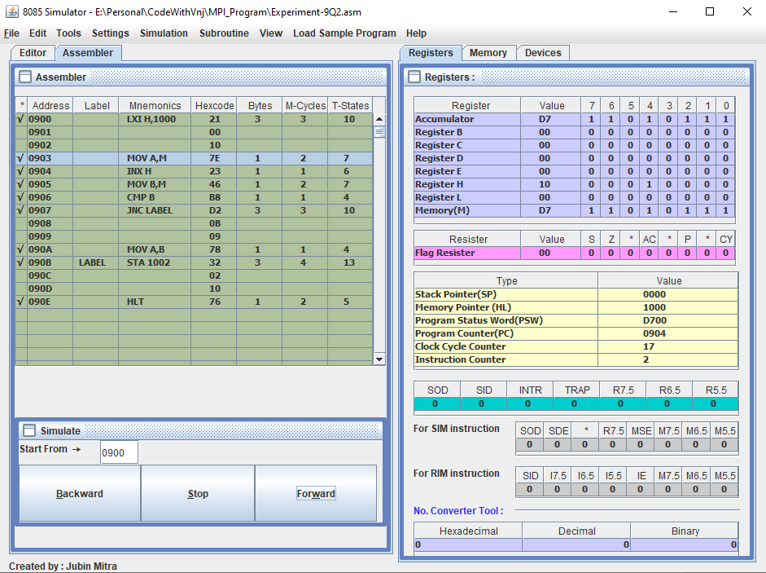

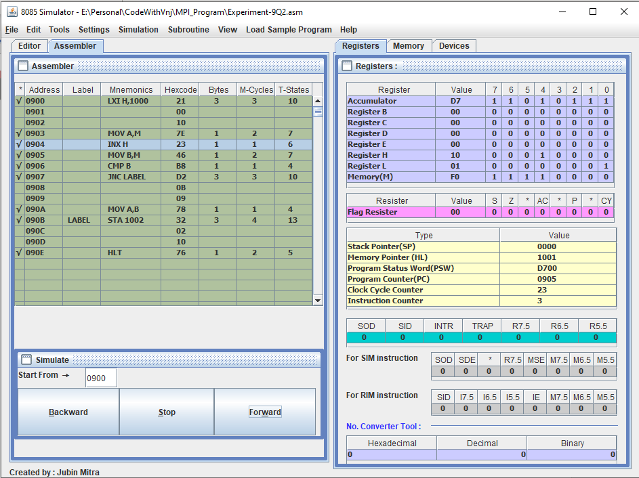

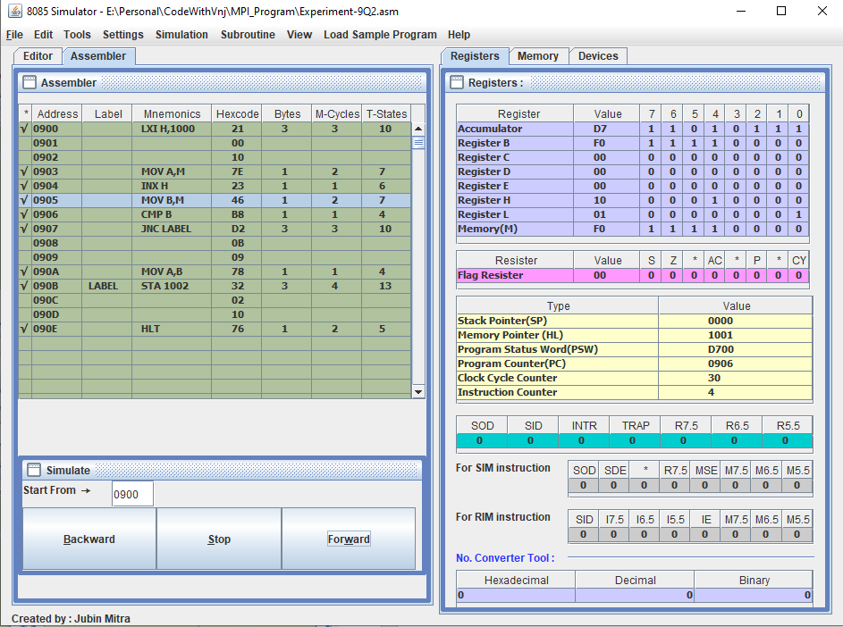

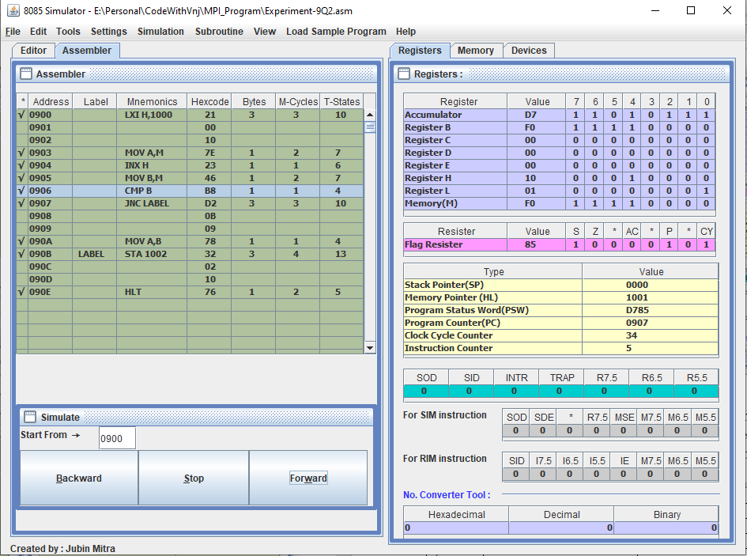

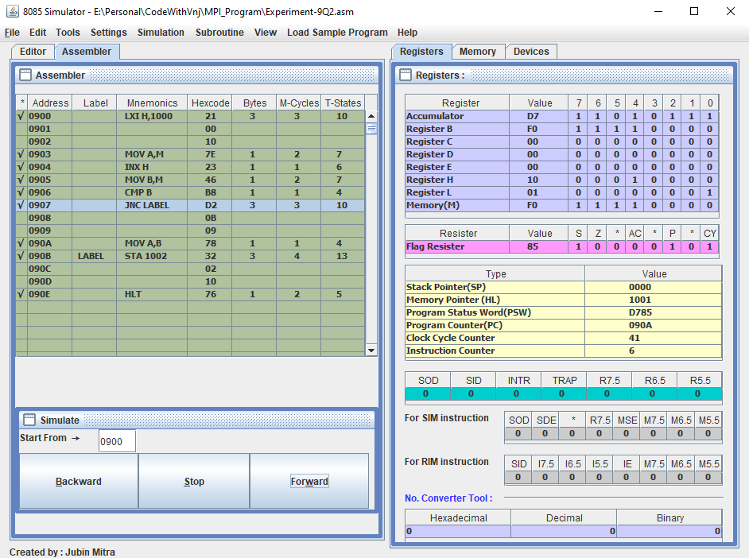

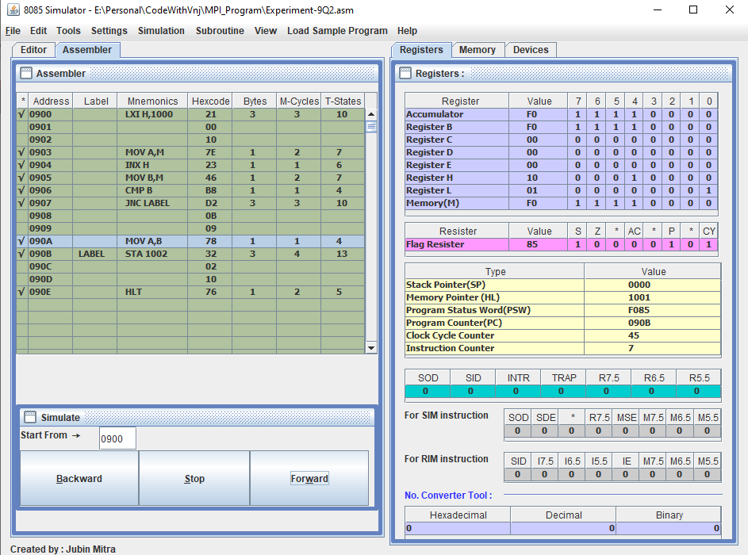

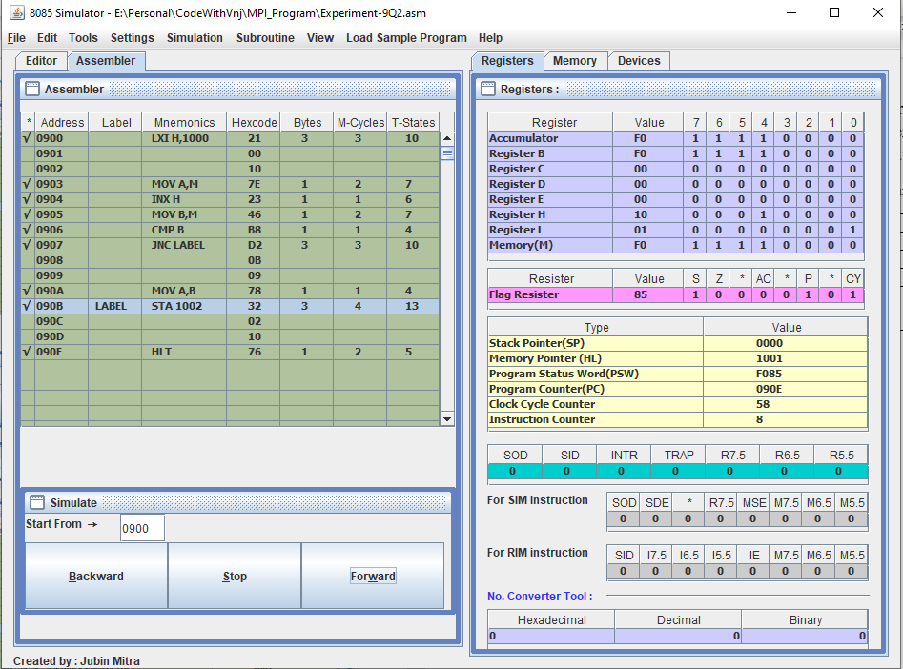

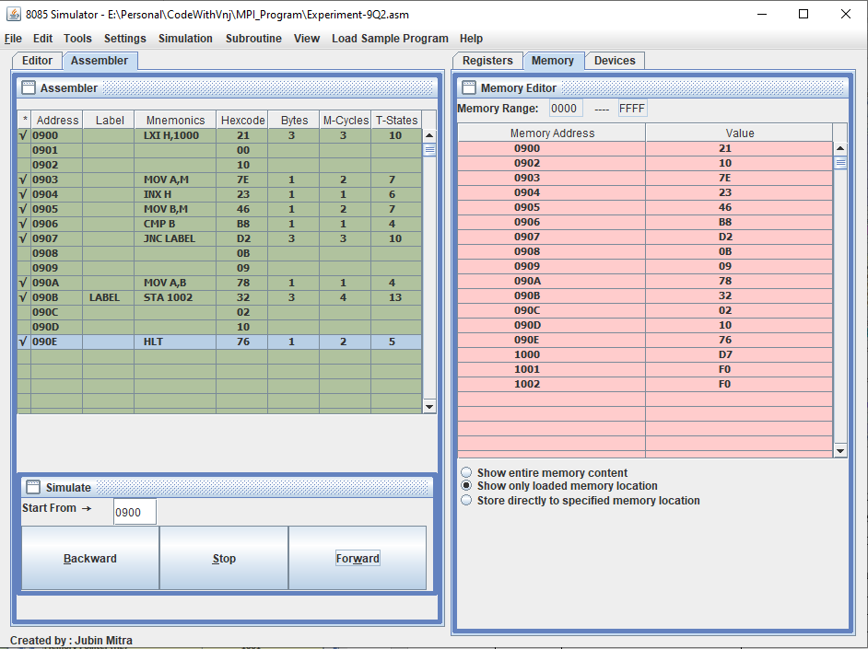

When 1st number is larger number

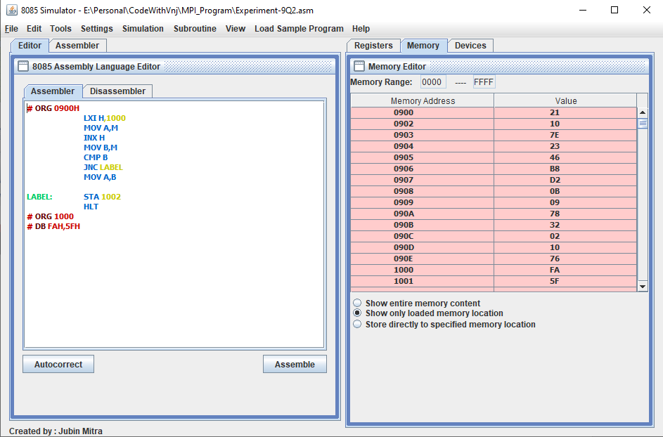

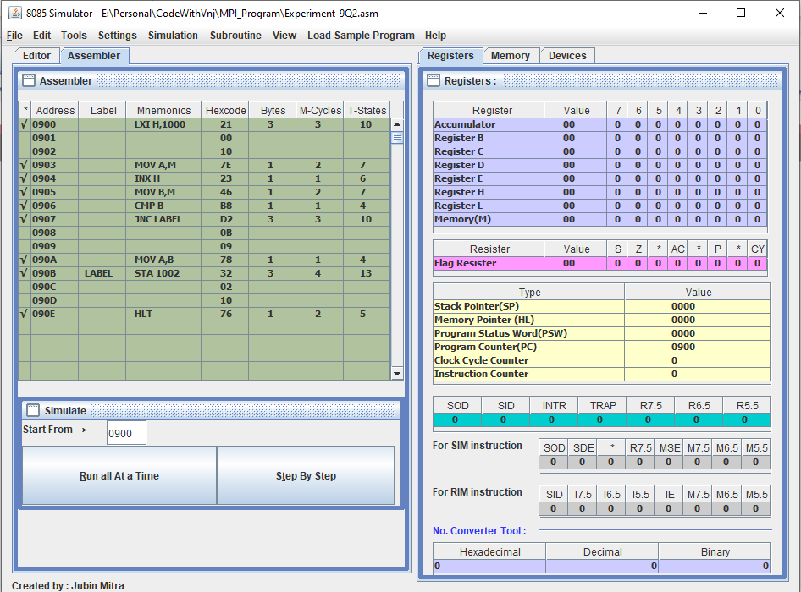

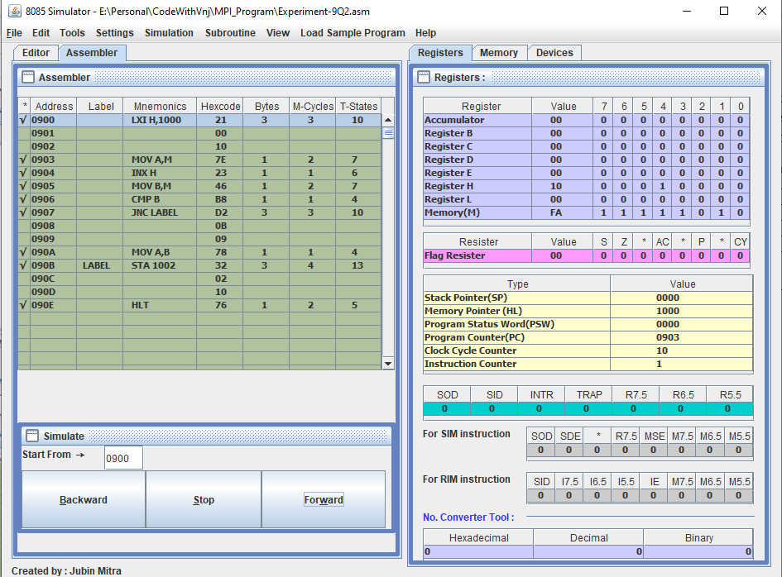

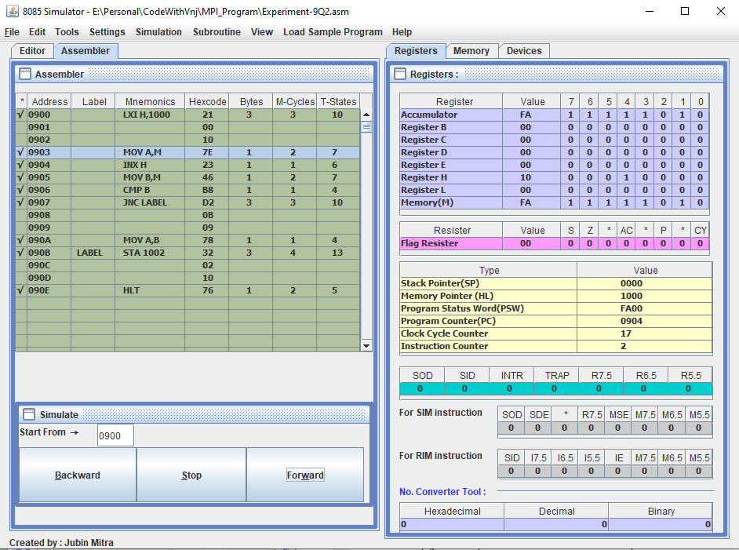

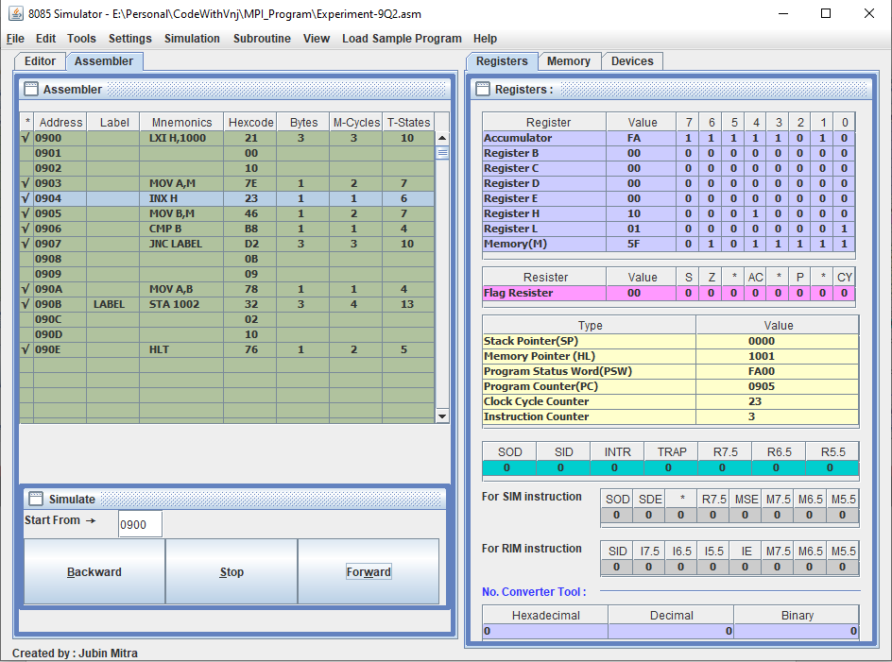

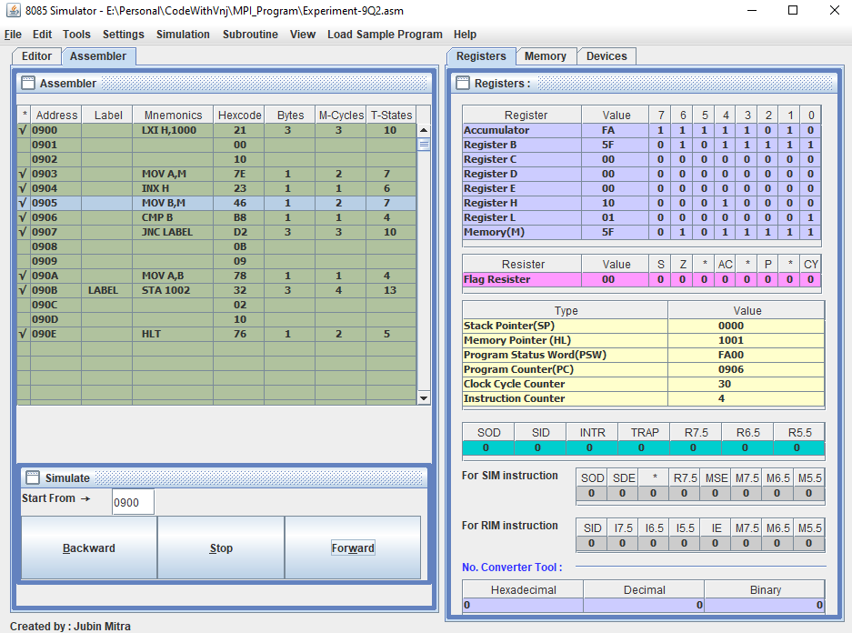

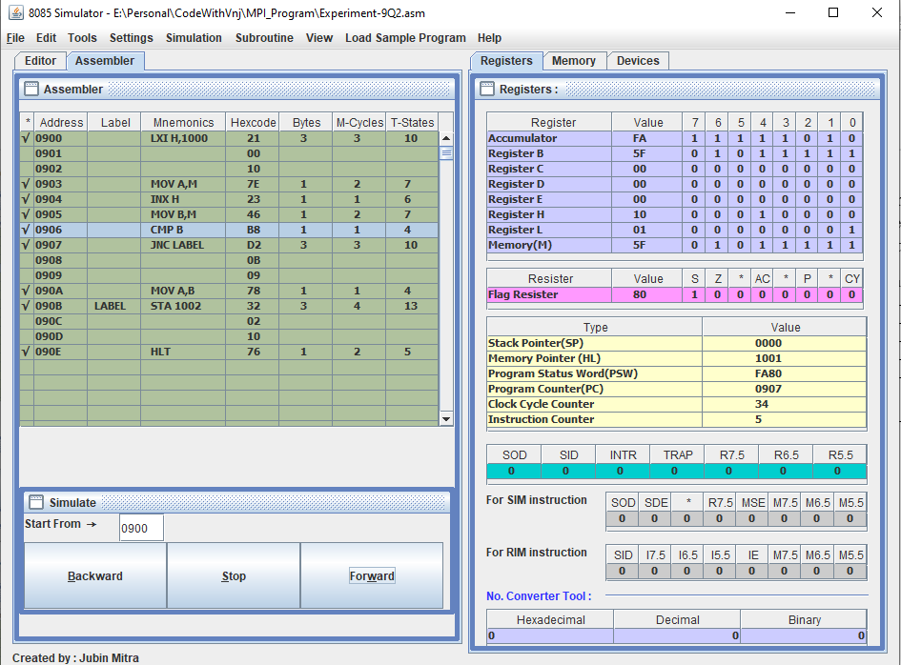

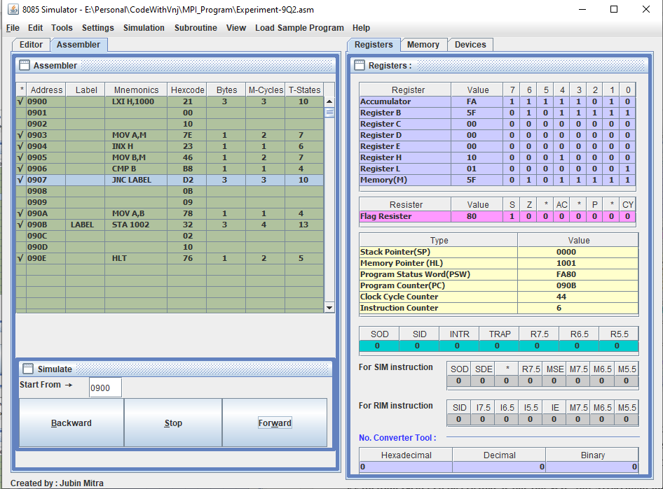

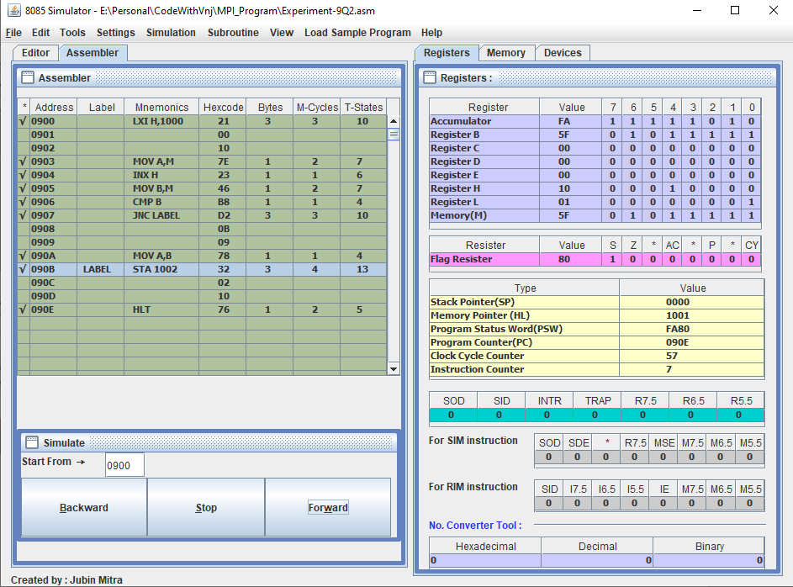

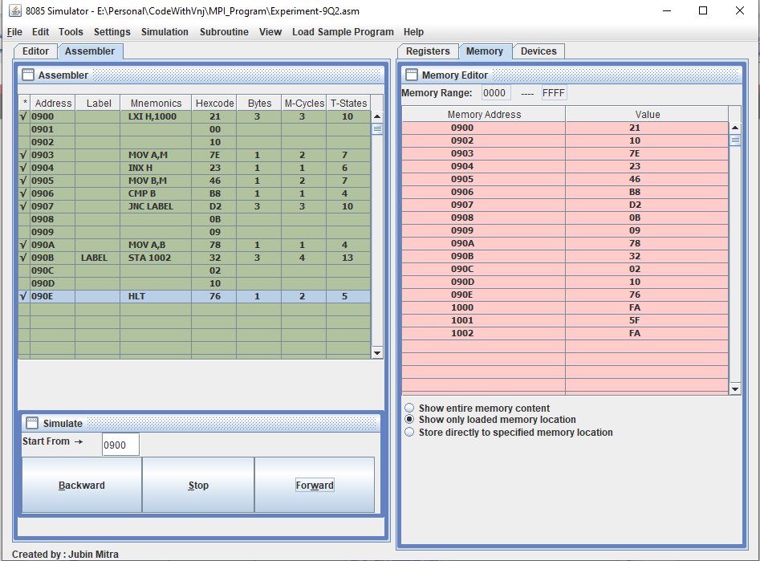

**Learning outcomes (What I have learnt):**

1. Learnt to find larger number in two number.
2. Learnt to find smaller number in two number.

**Evaluation Grid (To be created as per the SOP and Assessment guidelines by the faculty):**

|  |  |  |  |
| --- | --- | --- | --- |
| Sr. No. | Parameters | Marks Obtained | Maximum Marks |
| 1. |  |  |  |
| 2. |  |  |  |
| 3. |  |  |  |
|  |  |  |  |